#### CHAPTER 1

#### INTRODUCTION

* 1. **OBJECTIVE**

During my internship period at "**FRONTLINE TECHNOLOGIES**", I was able to develop my Good knowledge in HTML and CSS. I particularly had direct interactions with the company staff who helped me develop the project “**OUR SCHOOL WEBSITE**” along with my batch mates using the concepts of **HTML** and **CSS**. I believe this internship will be valuable in developing my thoughts and knowledge in Web development.

#### CHAPTER 2

#### TECHNOLOGY LEARNT

## 2.1 HTML

* HTML stands for **H**yper**t**ext **M**arkup **L**anguage, and it is the most widely used language to write Web Pages.
* **Hypertext** refers to the way in which Web pages (HTML documents) are linked together. Thus, the link available on a webpage is called Hypertext.
* As its name suggests, HTML is a **Markup Language** which means you use HTML to simply "mark-up" a text document with tags that tell a Web browser how to structure it to display.
* Originally, HTML was developed with the intent of defining the structure of documents like headings, paragraphs, lists, and so forth to facilitate the sharing of scientific information between researchers.

## 2.2 CSS:

* **C**ascading **S**tyle **S**heets, fondly referred to as CSS, is a simple design language intended to simplify the process of making web pages presentable.
* ­­­CSS handles the look and feel part of a web page. Using CSS, you can control the color of the text, the style of fonts, the spacing between paragraphs, how columns are sized and laid out, what background images or colors are used, layout designs, variations in display for different devices and screen sizes as well as a variety of other effects.

#### CHAPTER 3

#### PROJECT DESCRIPTION

### 3.1 METHODOLOGY

Developing a website requires careful planning and a structured approach to ensure it meets its objectives and serves its intended purpose effectively. Here's a general methodology to guide you through the website development process by following User Friendly Design, Course Information,Teacher Details, Contact Information.

**Responsive and User-Friendly Design**:

The school webpage should be designed to provide an optimal viewing experience across various devices, including desktops, tablets, and smart phones. It should have a clean and user-friendly layout that is easy to navigate, ensuring that users can access information without difficulty..

**Course Information**

The "Courses" section will provide comprehensive information about the courses offered by the school. Courses will be categorized by subject, grade level, and type (e.g., core subjects, elective courses).Each course will have a detailed description, objectives, prerequisites, and learning outcomes.

**Teacher Details**

A dedicated "Faculty" or "Teachers" section will be created on the webpage. Each teacher will have a name, educational background, areas of expertise, and contact information.

**Contact Information**

Each teacher's profile will include contact information, such as email addresses or contact forms, for users to reach out with questions or inquiries.

**CHAPTER 4**

# PROJECT OUTCOME

The project outcome for a our school website should be a fully functional and user-friendly website that effectively promotes and provides information about the school event. The main benefits of this website include:

1. Easy to use: It gives more flexibility to the for the users who are want

to book the classes.

2. More Interactive: The more interactive sessions can be booked

through the website.

3. Enhanced User engagement: This website is more engaged the user.

Overall, This website will gives the interactive and enhance the user

experience to school website.

**CHAPTER 5**

**PROJECT CODE**

#### 5.1 HTML & CSS Code For Home Page

<!DOCTYPE html>

<html>

<head>

<style type="text/css">

*

{

margin:0;

box-sizing:border-box

}

#sch

{

background-color: aqua;

width:100%;

display:table;

}

.new

{

width:33.33%;

float:left;

}

.new>ul{

list-style-type: none;

text-align: right;

}

.new>ul>li{

display: inline-block;

padding :10px;

font-weight: bold;

}

.new>ul>li>a{

color: navy;

text-decoration:none ;

}

.frontslide

{

position: relative;

display: block;

}

.slide1,.slide2,.slide3

{

position: absolute;

top:0;

left:0;

opacity:0;

animation-duration: 12s;

animation-iteration-count:infinite;

animation-name:slides;

margin: 0 auto;

}

@keyframes slides

{

0%

{

opacity:0;

}

25%

{

opacity:1;

}

50%

{

opacity:1;

}

75%

{

opacity:0;

}

100%

{

opacity:0;

}

}

.slide1

{

animation-delay: 0s;

}

.slide2

{

animation-delay: 4s;

}

.slide3

{

animation-delay: 8s;

}

</style>

</head>

<body>

<div id="sch">

<div class="new">

<img src="C:\Users\ELCOT\Desktop\ksr\sch.png "width="75px" height="75px">

</div>

<div class="new"style="padding-top:12.5px;">

<h4 style="text-align: center;">

GOVERNMENT HIGHER SECONDARY SCHOOL

</h4>

<h4 style="text-align: center;">

PERIYAKULATHUPPALAYAM

</h4>

<h4 style="text-align: center;">

KARUR 639006

</h4>

</div>

<div class="new">

<ul style="padding-top:10px;">

<li><a href="home.html" target="_blank">Home</a></li>

<li><a href="about.html"target="_blank">About</a></li>

<li><a href="det.html"target="_blank">Details</a></li>

<li><a href="add.html"target="_blank">Address</a></li>

</ul>

</div>

</div>

<br><br><br>

<h2><marquee style="color: rgb(7, 88, 123); ">தமிழ்நாடு அரசு பள்ளி கல்வி துறை</marquee></h2>

<br><br><br><br><br><br><br>

<div class="frontslide">

<div class="slide1">

<p style="text-align: center;">

<img src="sc1.jpg">

</p>

</div>

<div class="slide2">

<p style="text-align: center">

<img src="sc2.jpg">

</p>

</div>

<div class="slide3">

<p style="text-align: center">

<img src="sc3.jpg">

</p>

</div>

</div>

</body>

</html>

**5.2 HTML & CSS** **Code For About page**

<!DOCTYPE html>

<html>

<head>

<style type="text/css">

.a{

background:radial-gradient(teal,gold,magenta);

}

</style>

</head>

<body>

<div class="new"style="padding-top:12.5px;">

<h4 style="text-align: center;">

GOVERNMENT HIGHER SECONDARY SCHOOL

</h4>

<h4 style="text-align: center;">

PERIYAKULATHUPPALAYAM

</h4>

<h4 style="text-align: center;">

KARUR 639006

</h4>

</div>

<div class="a">

<p style="text-align:justify">

GHSS, PERIYAKULATHUPALAYAM was established in 1975 and it is managed by the Department of Education. It is located in Urban area. It is located in KARUR block of KARUR district of Tamil Nadu. The school consists of Grades from 6 to 12. The school is Co-educational and it doesn't have an attached pre-primary section. The school is N/A in nature and is not using school building as a shift-school. Tamil is the medium of instructions in this school. This school is approachable by all weather road. In this school academic session starts in April.

The school has Government building. It has got 4 classrooms for instructional purposes. All the classrooms are in good condition. It has 2 other rooms for non-teaching activities. The school has a separate room for Head master/Teacher. The school has Barbed Wire Fencing boundary wall. The school has have electric connection. The source of Drinking Water in the school is Tap Water and it is functional. The school has 3 boys toilet and it is functional. and 4 girls toilet and it is functional. The school has a playground. The school has a library and has 1219 books in its library. The school does not need ramp for disabled children to access classrooms. The school has 6 computers for teaching and learning purposes and all are functional. The school is not having a computer aided learning lab. The school is Provided and Prepared in School Premises providing mid-day meal.

</p>

</div>

</body>

</html>

**5.3 HTML & CSS** **Code For Teacher’s Details Page**

<!DOCTYPE html>

<html>

<head>

<style type="text/css">

#as

{

width:100%;

display:table;

}

.a

{

width:33%;

float:left;

}

.a>ul>li{

padding: 10px;

font-size: 20px;

}

.a>ul{

list-style-type: none;

}

h3

{

color:red;

}

</style>

</head>

<body>

<div id="as">

<div class="a">

<h1 style="margin:20px;">COURSES OFFERED</h2>

<h2>SECONDARY COURSES</h2>

<UL>

<li><a href="6th.html">6th Standard</a></li>

<li><a href="7th.html">7th Standard</a></li>

<li><a href="8th.html">8th Standard</a></li>

<li><a href="9th.html">9th Standard</a></li>

<li><a href="10th.html">10th Standard</a></li>

</UL>

<h2>SENIOR SECONDARY COURSES</h2>

<UL>

<li><a href="11th.html">11th Standard</a></li>

<li><a href="12th.html">12th Standard</a></li>

</UL>

</h1>

</div>

<div class="a">

<h2>TEACHER'S DETAILS</h2>

<h3>Head Master</h3>

<h4>KANAGARAJ.K M.SC.,M.ED.,M.PHIL.,</h4>

<h3>Department of Tamil</h3>

<h4>i)RAMAYE M.A.,M.Ed.,PHD.,</h4>

<h4>ii)LOGAMBA M.A.,M.Ed.,</h4>

<h4>iii)GLORY SELVAMANI B.A.,B.ED.,</h4>

<H4>iv)HEMA B.A.,B.ED.,</H4>

<h3>Department of English</h3>

<h4>i)THANGAVEL M.A.,M.ED.,M.PHIL.,</h4>

<h4>ii)VIDHYA M.A.,M.ED.,</h4>

<h4>iii)LAKSHMI B.A.,B.ED.,</h4>

<H3>Department of Maths</H3>

<h4>i)KANNADHASAN M.SC.,M.ED.,M.PHIL.,</h4>

<h4>ii)JAYANTHI M.SC.,M.ED.,</h4>

<H4>iii)LALITHA B.SC.,B.ED.,</H4>

</div>

<div class="a">

<H3>Department of Physics</H3>

<h4>i)NITHYA M.SC.,M.ED.,M.PHIL.,</h4>

<H4>ii)DHANDAPANI M.SC.,M.BD.,</H4>

<H3>Department of Chemistry</H3>

<h4>i)MURUGAVALLI M.SC.,M.ED.,M.PHIL.,</h4>

<H4>ii)MURALI B.SC.,B.ED.,</H4>

<H3>Department of Biology</H3>

<h4>i)KIRSHNA KUMAR M.SC.,M.ED.,</h4>

<H4>ii)KAVITHA B.SC.,B.ED.,</H4>

<H3>Department of Computer Science</H3>

<h4>i)DHARMARAJ M.SC.,M.ED.,</h4>

<H3>Department of Social Science</H3>

<h4>i)KALI SELVI B.A.,B.ED.,</h4>

<H4>ii)GUNASEKARAN B.A.,B.ED.,</H4>

<H4>iii)AMUTHAB.A.,B.ED.,</H4>

<H3>Department of Physical Activity</H3>

<h4>i)MANIMARAN</h4>

<H3>Department of Drawing</H3>

<h4>i)RAMABASKAR</h4>

</div>

</div>

</body>

</html>

**5.4 HTML & CSS** **Code For Courses Offered Page**

6th

<!DOCTYPE html>

<html>

<head>

<style type="text/css">

*

{

margin: 30px 50px;

}

.a{

background:radial-gradient(yellow,orange,red);

padding:30px;

}

table,tr,th,td{

border: 2px solid black;

border-collapse: collapse;

}

</style>

</head>

<body>

<div class="a">

<table>

<thead>

<tr>

<th>Course</th>

<th>Medium</th>

<th>Subjects</th>

<th>No.Of.Sets Available</th>

</tr>

</thead>

<tbody>

<tr>

<td>6th</td>

<td>Tamil&English</td>

<td>Tamil,Engllish,Maths,Science,Social Science</td>

<td>120(Both Tamil & English Medium)</td>

</tr>

</tbody>

</table>

</div>

</body>

</html>

**7th**

<!DOCTYPE html>

<html>

<head>

<style type="text/css">

*

{

margin: 30px 50px;

}

.a{

background:radial-gradient(yellow,orange,red);

padding:30px;

}

table,tr,th,td{

border: 2px solid black;

border-collapse: collapse;

}

</style>

</head>

<body>

<div class="a">

<table>

<thead>

<tr>

<th>Course</th>

<th>Medium</th>

<th>Subjects</th>

<th>No.Of.Sets Available</th>

</tr>

</thead>

<tbody>

<tr>

<td>7th</td>

<td>Tamil&English</td>

<td>Tamil,Engllish,Maths,Science,Social Science</td>

<td>120(Both Tamil & English Medium)</td>

</tr>

</tbody>

</table>

</div>

</body>

</html>

**8th**

<!DOCTYPE html>

<html>

<head>

<style type="text/css">

*

{

margin: 30px 50px;

}

.a{

background:radial-gradient(yellow,orange,red);

padding:30px;

}

table,tr,th,td{

border: 2px solid black;

border-collapse: collapse;

}

</style>

</head>

<body>

<div class="a">

<table>

<thead>

<tr>

<th>Course</th>

<th>Medium</th>

<th>Subjects</th>

<th>No.Of.Sets Available</th>

</tr>

</thead>

<tbody>

<tr>

<td>8th</td>

<td>Tamil&English</td>

<td>Tamil,Engllish,Maths,Science,Social Science</td>

<td>120(Both Tamil & English Medium)</td>

</tr>

</tbody>

</table>

</div>

</body>

</html>

**9th**

<!DOCTYPE html>

<html>

<head>

<style type="text/css">

*

{

margin: 30px 50px;

}

.a {

background:radial-gradient(yellow,orange,red);

padding:30px;

}

table,tr,th,td{

border: 2px solid black;

border-collapse: collapse;

}

</style>

</head>

<body>

<div class="a">

<table>

<thead>

<tr>

<th>Course</th>

<th>Medium</th>

<th>Subjects</th>

<th>No.Of.Sets Available</th>

</tr>

</thead>

<tbody>

<tr>

<td>9th</td>

<td>Tamil&English</td>

<td>Tamil,Engllish,Maths,Science,Social Science</td>

<td>150(Both Tamil & English Medium)</td>

</tr>

</tbody>

</table>

</div>

</body>

</html>

**10th**

<!DOCTYPE html>

<html>

<head>

<style type="text/css">

*

{

margin: 30px 50px;

}

.a

{

background:radial-gradient(yellow,orange,red);

padding:30px;

}

table,tr,th,td{

border: 2px solid black;

border-collapse: collapse;

}

</style>

</head>

<body>

<div class="a">

<table>

<thead>

<tr>

<th>Course</th>

<th>Medium</th>

<th>Subjects</th>

<th>No.Of.Sets Available</th>

</tr>

</thead>

<tbody>

<tr>

<td>10th</td>

<td>Tamil&English</td>

<td>Tamil,Engllish,Maths,Science,Social Science</td>

<td>150(Both Tamil & English Medium)</td>

</tr>

</tbody>

</table>

</div>

</body>

</html>

**11th**

<!DOCTYPE html>

<html>

<head>

<style type="text/css">

*

{

margin: 30px 50px;

}

.a

{

background:radial-gradient(yellow,orange,red);

padding:30px;

}

table,tr,th,td{

border: 2px solid black;

border-collapse: collapse;

}

</style>

</head>

<body>

<div class="a">

<h3>GROUP 1 (BIO & MATHS)</h3>

<table>

<thead>

<tr>

<th>Course</th>

<th>Medium</th>

<th>Subjects</th>

<th>No.Of.Sets Available</th>

</tr>

</thead>

<tbody>

<tr>

<td>11th</td>

<td>Tamil&English</td>

<td>Tamil,Engllish,Maths,Physics,Chemistry,Biology</td>

<td>200(Both Tamil & English Medium)</td>

</tr>

</tbody>

</table>

<h3>GROUP 2 (COMPUTER SCIENCE & MATHS)</h3>

<table>

<thead>

<tr>

<th>Course</th>

<th>Medium</th>

<th>Subjects</th>

<th>No.Of.Sets Available</th>

</tr>

</thead>

<tbody>

<tr>

<td>11th</td>

<td>Tamil&English</td>

<td>Tamil,Engllish,Maths,Physics,Chemistry,Computer Science</td>

<td>200(Both Tamil & English Medium)</td>

</tr>

</tbody>

</table>

</body>

</html>

**12th**

<!DOCTYPE html>

<html>

<head>

<style type="text/css">

*

{

margin: 30px 50px;

}

.a

{

background:radial-gradient(yellow,orange,red);

padding:30px;

}

table,tr,th,td{

border: 2px solid black;

border-collapse: collapse;

}

</style>

</head>

<body>

<div class="a">

<h3>GROUP 1 (BIO & MATHS)</h3>

<table>

<thead>

<tr>

<th>Course</th>

<th>Medium</th>

<th>Subjects</th>

<th>No.Of.Sets Available</th>

</tr>

</thead>

<tbody>

<tr>

<td>12th</td>

<td>Tamil&English</td>

<td>Tamil,Engllish,Maths,Physics,Chemistry,Biology</td>

<td>200(Both Tamil & English Medium)</td>

</tr>

</tbody>

</table>

<h3>GROUP 2 (COMPUTER SCIENCE & MATHS)</h3>

<table>

<thead>

<tr>

<th>Course</th>

<th>Medium</th>

<th>Subjects</th>

<th>No.Of.Sets Available</th>

</tr>

</thead>

<tbody>

<tr>

<td>12th</td>

<td>Tamil&English</td>

<td>Tamil,Engllish,Maths,Physics,Chemistry,Computer Science</td>

<td>200(Both Tamil & English Medium)</td>

</tr>

</tbody>

</table>

</body>

</html>

**5.5 HTML & CSS** **Code For Contact Page**

<!DOCTYPE html>

<html>

<body style="text-align: center;">

<h4>

GOVERNMENT HIGHER SECONDARY SCHOOL

</h4>

<h4>

PERIYAKULATHUPPALAYAM

</h4>

<h4>

KARUR 639006

</h4><br><br>

<iframe src="https://www.google.com/maps/embed?pb=!1m18!1m12!1m3!1d3916.8189487460995!2d78.06258187443812!3d10.977034589184148!2m3!1f0!2f0!3f0!3m2!1i1024!2i768!4f13.1!3m3!1m2!1s0x3baa2f98f47b6d29%3A0x54dcb3d50d1e28ea!2sGovt%20Higher%20Secondary%20School%20(PeriyaKulathupalayam)!5e0!3m2!1sen!2sin!4v1690470756658!5m2!1sen!2sin" width="600" height="450" style="border:0;" allowfullscreen="" loading="lazy" referrerpolicy="no-referrer-when-downgrade" width="300px"></iframe>

</body>

<h2 style="text-align: right;">Contact:9890171665</h2>

</html>

#### CHAPTER 6

#### SCREENSHOTS

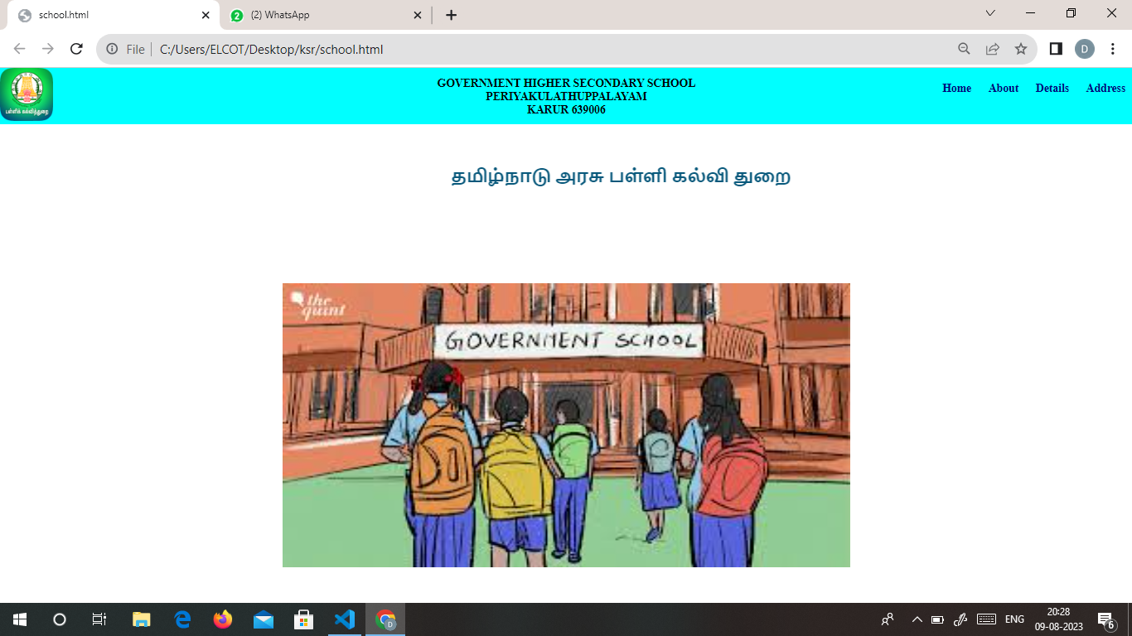

6.1Home page Screenshots

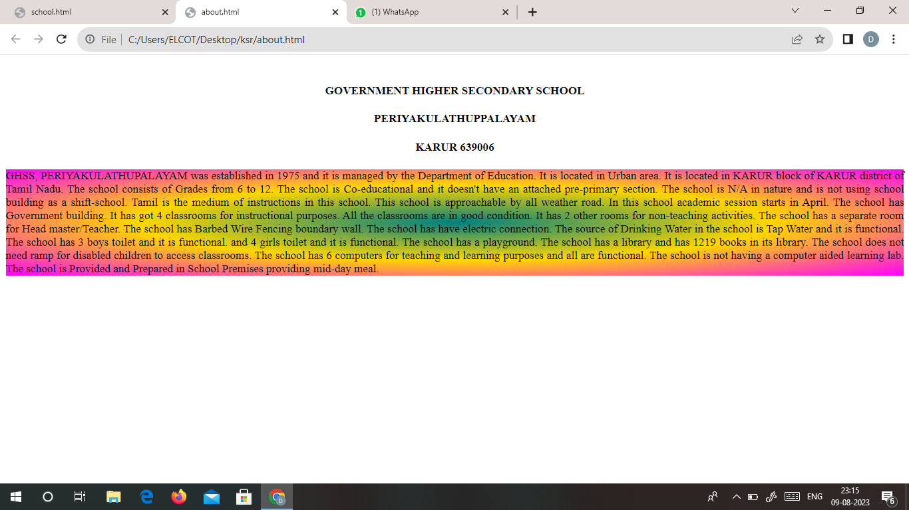

6.2 About us page Screenshots

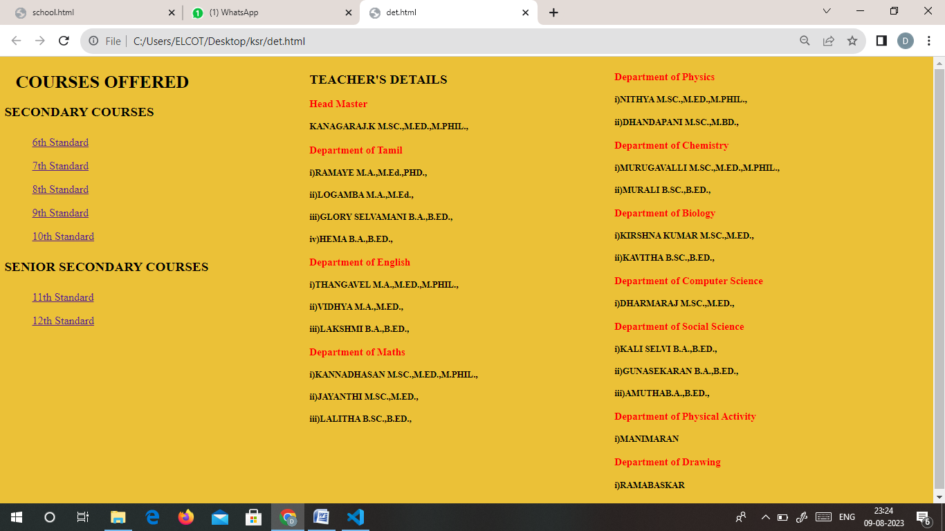

6.3 Teacher’s Details Page Screenshots

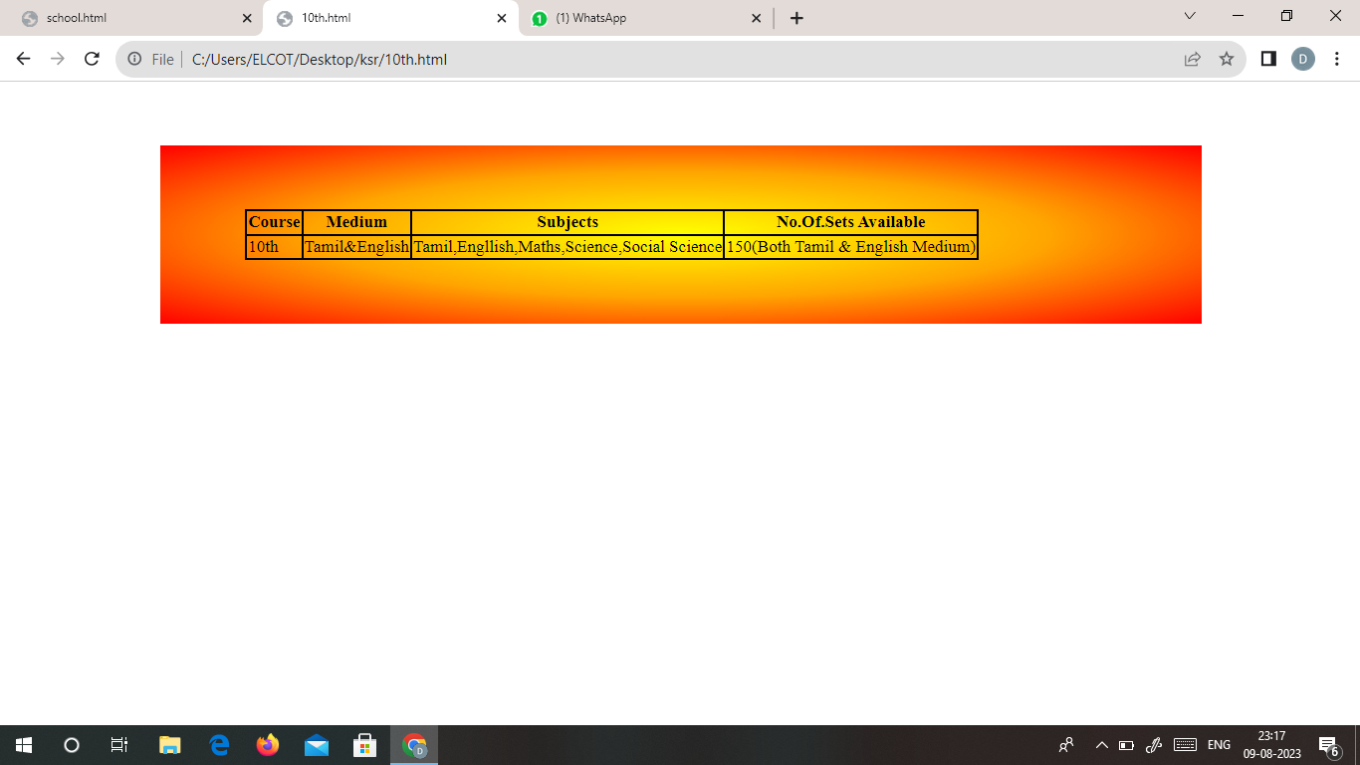

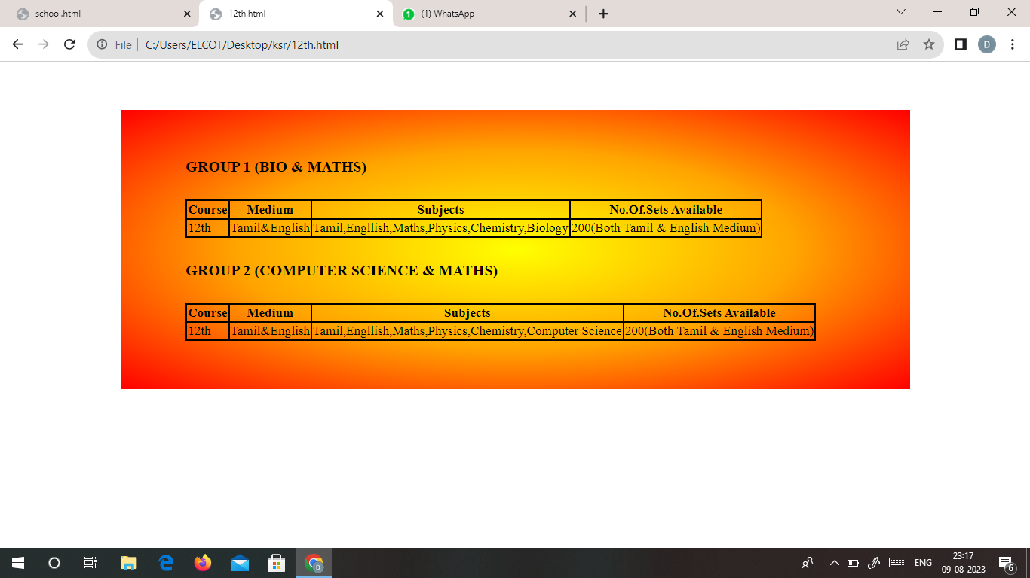

6.4 Courses Offered Page Screenshots

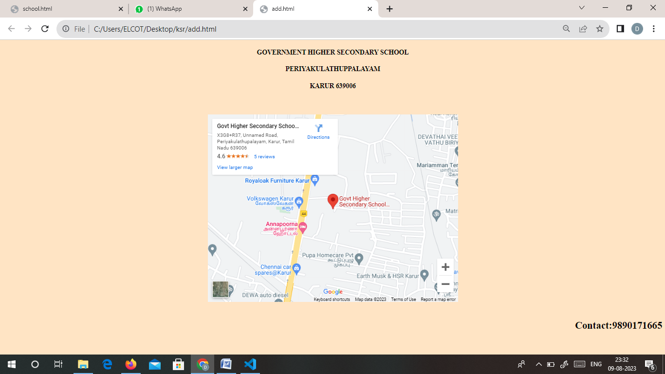

6.5 Contact us page Screenshots

**CHAPTER 7**

**CONCLUSION**

In conclusion, the creation of our school's web page marks a significant stride towards enhancing communication and engagement within our educational community. By seamlessly integrating crucial information such as teacher profiles, contact details, and comprehensive course information, we have crafted a virtual hub that serves as a gateway to an enriched learning experience. Through this platform, students, parents, and staff can easily access up-to-date information about our dedicated educators, fostering a stronger sense of connection and transparency. The provision of detailed course descriptions empowers students to make informed decisions about their academic journeys, while the readily available contact information ensures that communication lines remain open and efficient. As we embrace the digital age, this web page stands as a testament to our commitment to innovation and excellence in education. By providing a user-friendly, informative, and aesthetically pleasing interface, we aim to enhance the overall school experience for all stakeholders. We look forward to witnessing the positive impact this web page will have on communication, accessibility, and collaboration, ultimately contributing to the growth and success of our school community.

**CHAPTER 8**

**INTERNSHIP OFFER LETTER**

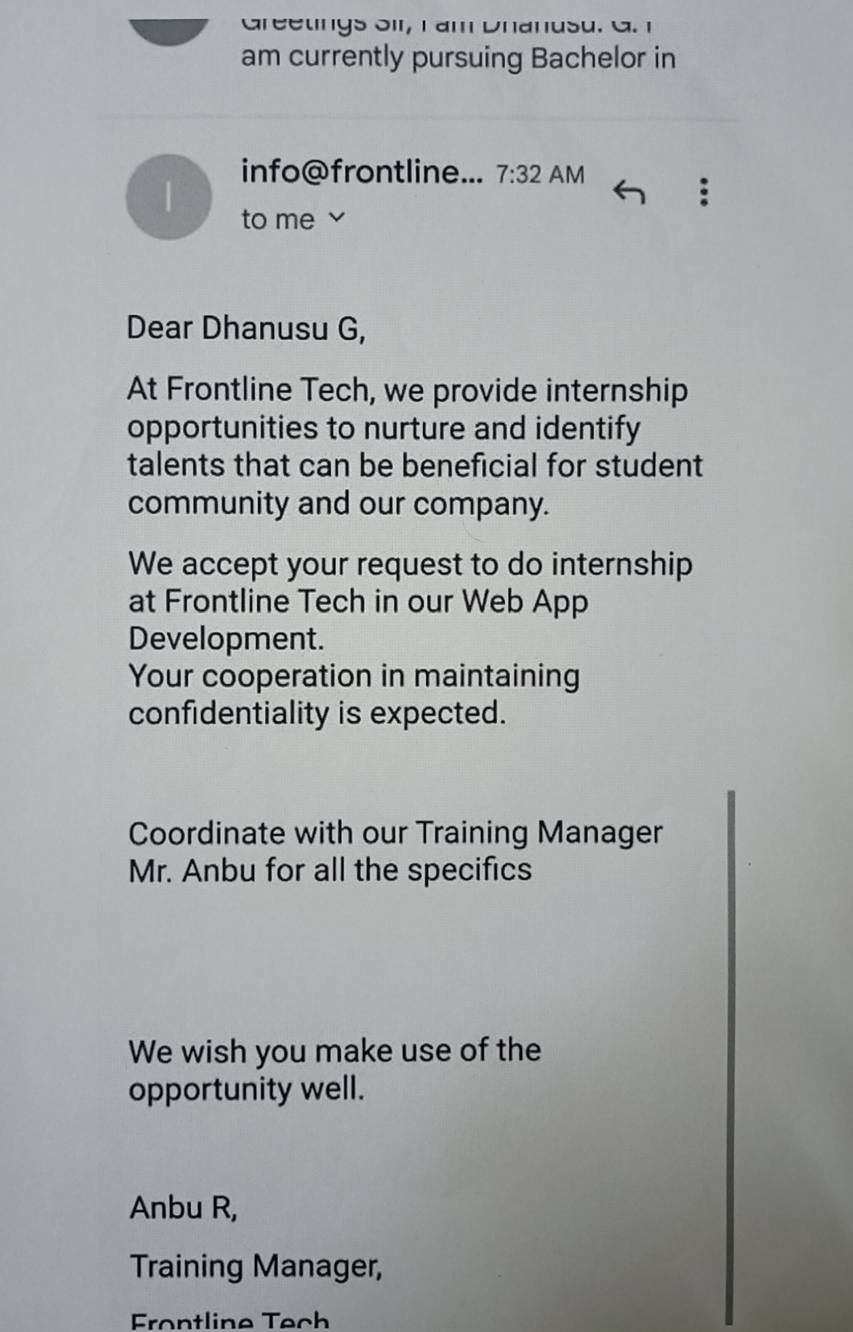

**INTERNSHIP** **CERTIFICATE :**

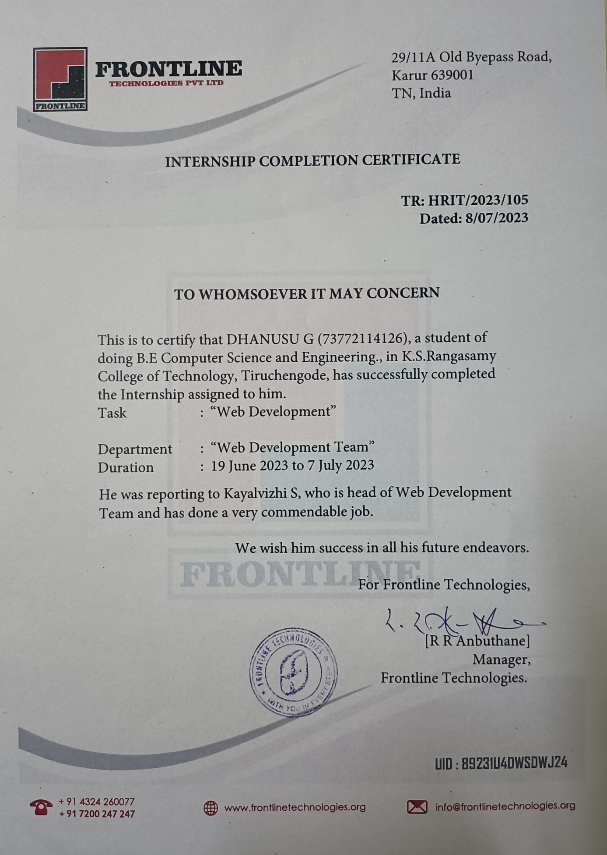**INTERNSHIP EVALUATION FORM:**

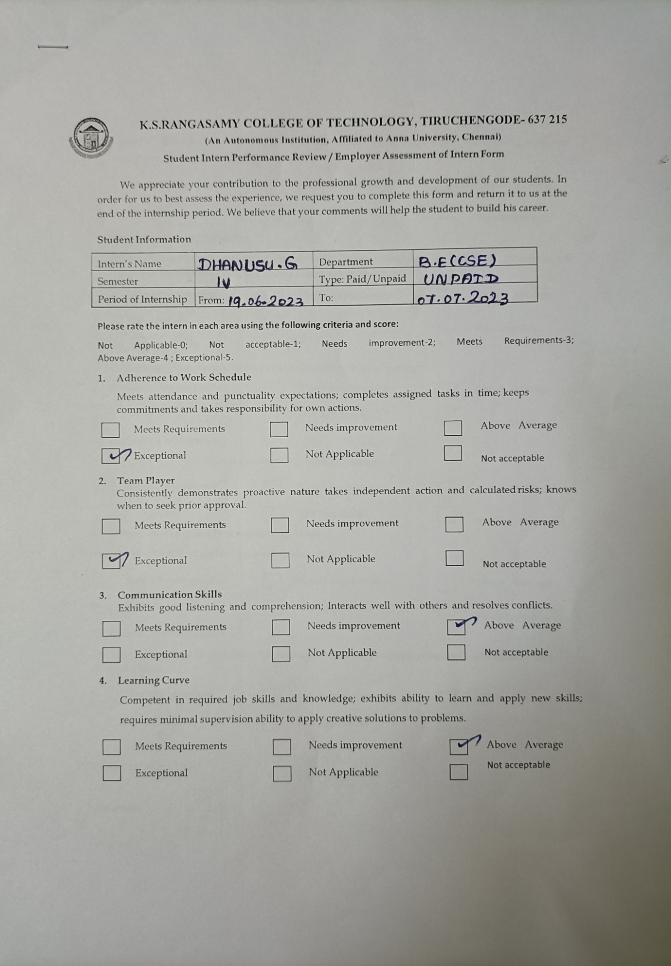

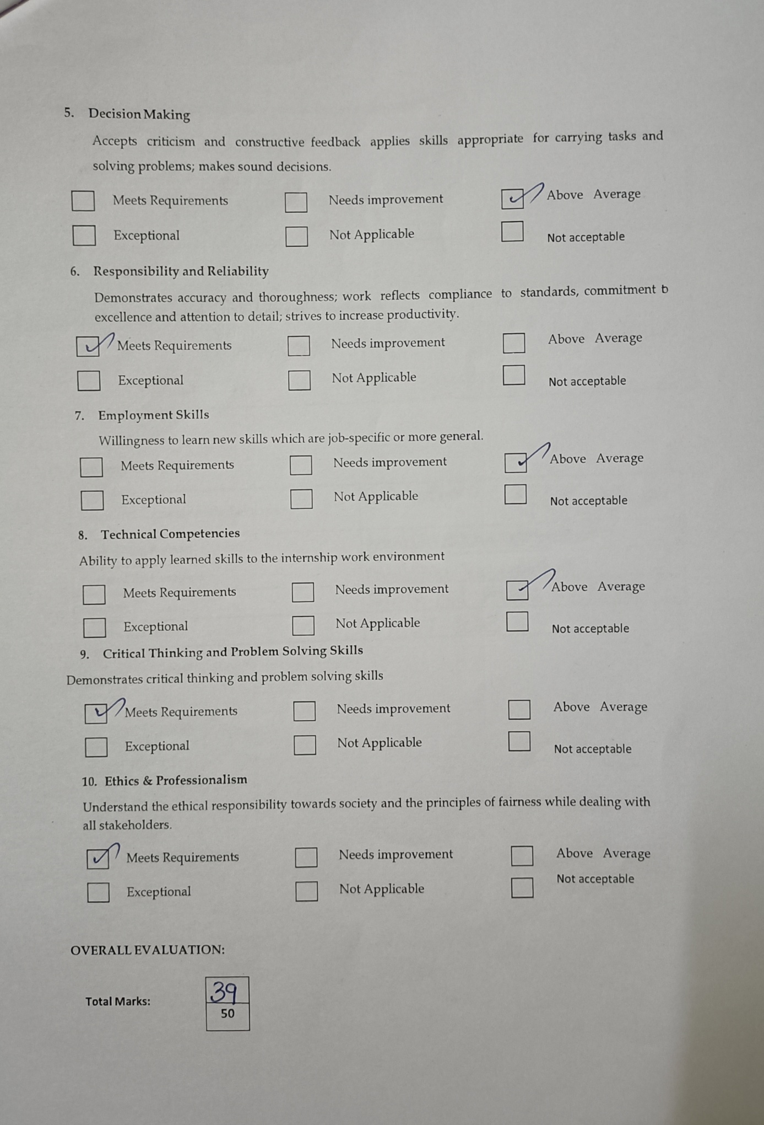

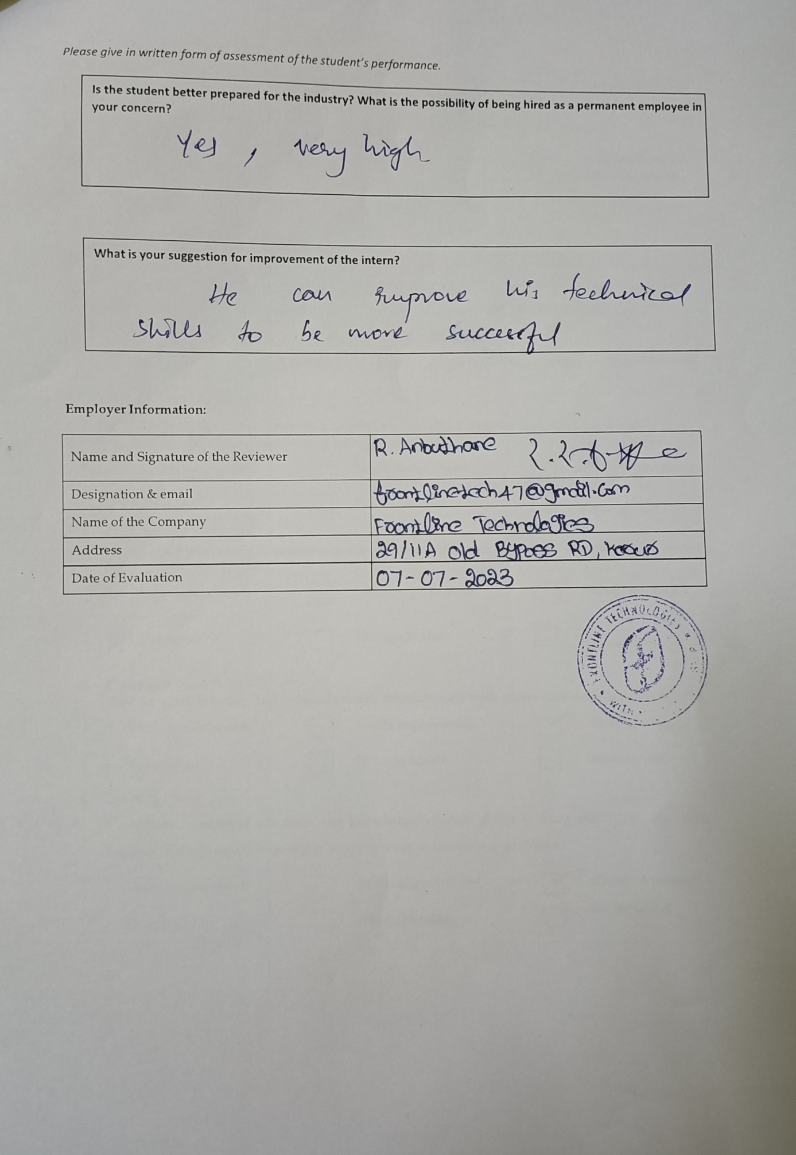

#### CHAPTER 9

#### REFERENCES

1. <https://www.w3schools.com/html/>
2. <https://www.codecademy.com/learn/learn-html>
3. <https://www.freecodecamp.org/news/learn-html-beginners-course/>
4. <https://www.w3schools.com/css/>
5. <https://gitconnected.com/learn/css>